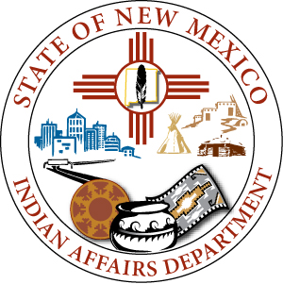
  - 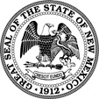

Lynn Trujillo
Cabinet Secretary

Nadine Padilla
Deputy Cabinet Secretary

STATE OF NEW MEXICO
INDIAN AFFAIRS DEPARTMENT
Office of the Secretary
Willie Ortiz Building, Basement
2600 Cerrillos Road
Santa Fe, NM 87505
Phone (505) 476-1600
Fax (505) 476-1601
www.iad.state.nm.us

Michelle Lujan Grisham

Governor

Howie Morales

Lieutenant Governor

Tribal Infrastructure Fund
Board Meeting
Room 322, State Capitol Building
Wednesday, May 18, 2022
9:00 a.m.

AGENDA

- Call to Order, Roll Call Chair Secretary Trujillo

- Welcome and Introductions Chair Secretary Trujillo

- Approval of Agenda Chair Secretary Trujillo

- Approval of Meeting Minutes Chair Secretary Trujillo

- December 10, 2021 - Meeting Minutes

- New Business:
  - Tribal Infrastructure Fund Applicant Presentations – 10 minutes
- Coyote Canyon Chapter Waterline Extension North/South
- Ohkay Owingeh Drainage Master Plan Improvement
- Baca Chapter Water System Improvement
- Santa Ana Pueblo Public Safety, Judicial, Social Services Complex
- Santa Ana Pueblo Tribal Administration Complex
- Huerfano Chapter Caron-Burnham Regional Water System
- Zuni Pueblo Fair Building
- Pojoaque Pueblo Water/Wastewater System Improvement
- Santo Domingo Pueblo Wastewater Project
- Thoreau Chapter 371 Regional Supply Project
- Mescalero Apache Tribe Eagle Creek Service Route 21 & 90
- Mescalero Apache Tribe Carrizo Fire Hydrants, Water System & Wells
- Church Rock Chapter Superman Canyon Road and Bridge Improvement
- Chichiltah Chapter New Wastewater
- Santa Clara Pueblo Water System – Canyon Road
- Santa Clara Pueblo Emergency Radio Communications Upgrade
- San Ildefonso Pueblo Deer Tail Vista Housing Subdivision Infrastructure Phase 2
  - Tribal Infrastructure Fund Appropriation Awards and Resolution, Notification and Certification to the State Board of Finance to Sell Severance Tax Bonds

- Next Meeting Discussion Chair Secretary Trujillo

- Adjournment Chair Secretary Trujillo

