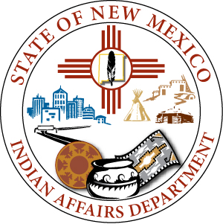
  - 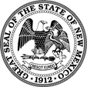

Lynn Trujillo
Cabinet Secretary

Nadine Padilla
Deputy Cabinet Secretary

Michelle Lujan Grisham

Governor

Howie Morales
Lieutenant Governor

STATE OF NEW MEXICO
INDIAN AFFAIRS DEPARTMENT
Wendell Chino Building, 2nd Floor
1220 S. St. Francis Dr.
Santa Fe, NM 87505
Phone (505) 476-1600
Fax (505) 476-1601
www.iad.state.nm.us

MISSING AND MURDERED INDIGENOUS WOMEN TASK FORCE
MEETING AGENDA

Date: Friday, November 8, 2019
Time: 12:00-5:00PM
Location: Board Room at CNM Main Campus (SRC Building) at 525 Buena Vista Dr. SE, Albuquerque, NM 87106

Objective: The MMIW Task Force (TF) will meet to define goals and develop a strategy for 1) understanding the full extent of missing and murdered indigenous women in the state, and; 2) creating a final report that meets the requirements of HB 278, that is based on community ideas and recommendations, and that is useful to communities, tribal governments, law enforcement agencies and state agencies. There will be an opportunity for members to network and formally introduce themselves. The department will cover IPRA guidelines. The TF will develop member expectations, communication standards and operational protocols for the group in order to maintain IPRA compliance and meet legislative goals. The public will also have an opportunity to share their input and experiences. The ideas shared will help to inform the agenda for future meetings and recommendations for the final report.

Time | Agenda
12:00pm | Networking Lunch  Task force (TF) members will have the opportunity to meet and greet each other prior to the official meeting. Lunch will be provided.
1:00pm | Welcome  The meeting will begin with an opening prayer and remarks from Secretary Trujillo and Christine Means
1:20pm | Introductions  TF members and the Indian Affairs Department team will introduce themselves.
1:50pm | A brief overview of the agenda
1:55pm | Task Force Expectations, Standards and Protocols  The department will give a short presentation on the Inspection of Public Records Act. The TF will overview member expectations and roles, operational protocols, and communication standards and mechanisms.
2:20pm | Addressing the Crisis of MMIW  The TF will discuss strategy for: 1) understanding the full extent of missing and murdered indigenous women in the state, and; 2) creating a final report that meets the requirements of HB 278, that is based on community ideas and recommendations, and that is useful to communities, tribal governments, law enforcement agencies and state agencies. This discussion will help to define the TF goals, scope of work and plan for meeting the requirements of House Bill 278.
4:20pm | Public Comment  To understand the full extent of the problem and develop recommendations, public attendees will have the opportunity to share their input and experiences.
4:50pm | Wrap-up/Closing Remarks

IMPORTANT NOTICE: MEETING WILL BE TRANSCRIBED USING VIDEO/AUDIO RECORDING.

